LAB 4:

PART I:

5-bit Adder Subtractor:

1. 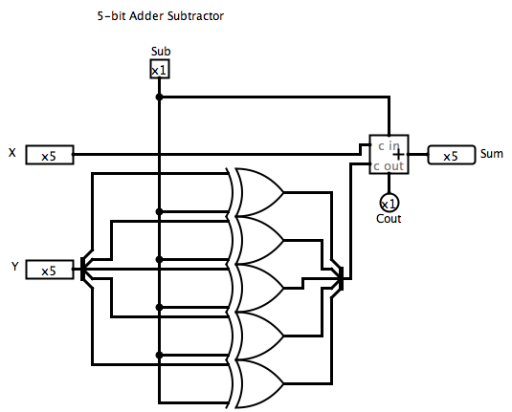

2. The Sub signal goes into the Cin of the adder due to the logic that goes into telling if a number will be negative or not. I forgot how Neal explained it, but somehow the circuit knows how to tell if the Sum will be negative. ALSO, the Sub signal goes into the Cin because here we do not have the add one function we had in our Tiny ALU, thus we need the Sub signal to tell the circuit that it is adding a negative number.

3.

|  |  |  |  |  |
| --- | --- | --- | --- | --- |
| **A** | **B** | **Sub** | **Sum** | **Cout** |
| x | y | 0 | x+y | (x+y+Sub) mod 25 |
| x | y | 1 | X+(-y) | 1 if (x+y+Sub)>25-1 |

4. 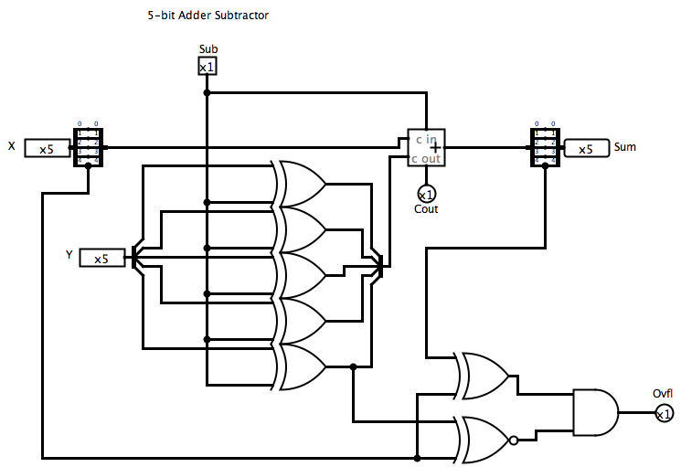

5.

|  |  |  |  |
| --- | --- | --- | --- |
| SignA | SignB | SignSum | **Ovfl** |
| 0 | 0 | 0 | 0 |
| 0 | 0 | 1 | 1 |
| 0 | 1 | 0 | 0 |
| 0 | 1 | 1 | 0 |
| 1 | 0 | 0 | 0 |
| 1 | 0 | 1 | 0 |
| 1 | 1 | 0 | 1 |
| 1 | 1 | 1 | 0 |

Part II:

1. 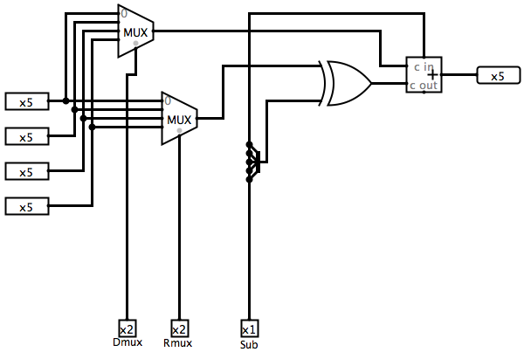

Questions:

1. The purpose of the Xor gate is to Or is to control the sub operator which can either add of subtract numbers.

2. The wiring next to the Xor gate is the logisim way of displaying what we had done in the previous circuit. In the previous circuit we had to use 5 Xor gates to split B, in this circuit we can use a splitter to separate the bundle and then tell logisim that there are 5 bits coming in, and therefore do split the operations 5 times.

3. It seems that there are 5 control bits

4. I would guess that this circuit could do 2 operations. It would seem that it can add or subtract two numbers.

5. This circuit could add A and B or subtract A and B. It could do the same for C and D. And although they are not labeled in my circuit the Inputs are ordered A-D from top to bottom.